BLACK DIAMOND NETWORKS SPRING 2018 CAMPUS TOUR
Meet our team…grab some cool items…and learn about career opportunities with an industry leader!
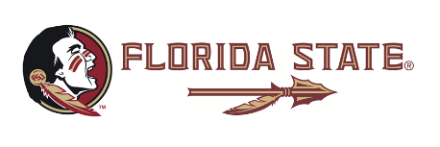 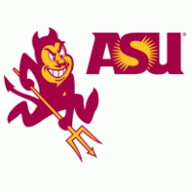 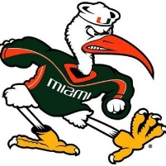
Florida State University Arizona State University University of Miami
January 25 February 14 February 21

University of New Hampshire Salem State University
February 27 March 1

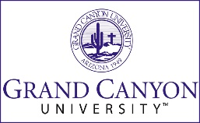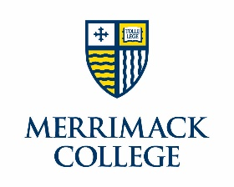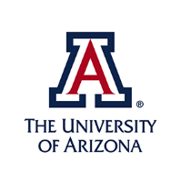
Grand Canyon University Merrimack College University of Arizona
March 15 March 15 March 20

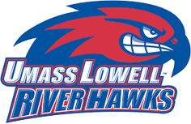
UMass Lowell Keene State College
March 21 March 22

